Entities Blueprint Documentation

1-Entities Template

Knowledge Base

✅ What does "Entities Template" mean?
# Source: AI Source: Provided by: [Data Path: Persons Table -> ID Column: 1, Name_En Column: Motasem Essam] -> From: [ChatGPT] on [8/8/2025]
The Entities Template is the standard structural blueprint that defines how all entities in your system are described, stored, and related — across both the Entity Types Table and the Entities Table.
It’s not a single table — it’s the set of rules and structure that both tables follow together.

Entities Template to be universal, capable of describing anything — whether it’s material (physical) or immaterial (abstract, digital, conceptual).

Rules and Guidelines

1-Entities structure

1.1-Core Design Principle
# Source: AI Source: Provided by: [Data Path: Persons Table -> ID Column: 1, Name_En Column: Motasem Essam] -> From: [ChatGPT] on [8/8/2025]
The Entities structure is the universal structural blueprint used to describe, define, and organize any entity in existence —
whether material (physical things) or immaterial (concepts, systems, digital objects, relationships, ideas).
It is the meta-standard that governs how entities are:
- Defined (via the Entity Types Table)
- Recorded (via the Entities Table)
- Connected, classified, and logged (via relationships and metadata)

From a philosophical or knowledge-engineering standpoint,
the Entities Template represents a universal ontology framework —
a system where everything that “exists” (in the mind, in code, or in the world) is treated as an Entity.
This means:
- Matter (objects, organisms, systems)
- Mind (thoughts, ideas, emotions)
- Meaning (symbols, data, software)
…can all coexist and interrelate inside one structured model.

1.2-Universal Scope
# Source: AI Source: Provided by: [Data Path: Persons Table -> ID Column: 1, Name_En Column: Motasem Essam] -> From: [ChatGPT] on [8/8/2025]
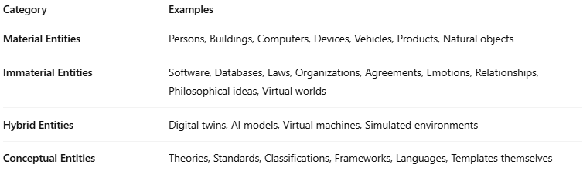
Category | Examples
Material Entities | Persons, Buildings, Computers, Devices, Vehicles, Products, Natural objects
Immaterial Entities | Software, Databases, Laws, Organizations, Agreements, Emotions, Relationships, Philosophical ideas, Virtual worlds
Hybrid Entities | Digital twins, AI models, Virtual machines, Simulated environments
Conceptual Entities | Theories, Standards, Classifications, Frameworks, Languages, Templates themselves

1.3-Structure
# Source: AI Source: Provided by: [Data Path: Persons Table -> ID Column: 1, Name_En Column: Motasem Essam] -> From: [ChatGPT] on [8/8/2025]
The Entities Template defines two complementary tables that together describe all forms of entities:
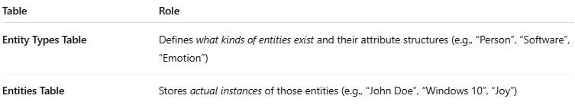
Table | Role
Entity Types Table | Defines what kinds of entities exist and their attribute structures (e.g., “Person”, “Software”, “Emotion”)
Entities Table | Stores actual instances of those entities (e.g., “John Doe”, “Windows 10”, “Joy”)
Each entity record points to an entity type that describes its nature and properties.

1.4-Attribute System Rules
# Source: AI Source: Provided by: [Data Path: Persons Table -> ID Column: 1, Name_En Column: Motasem Essam] -> From: [ChatGPT] on [8/8/2025]
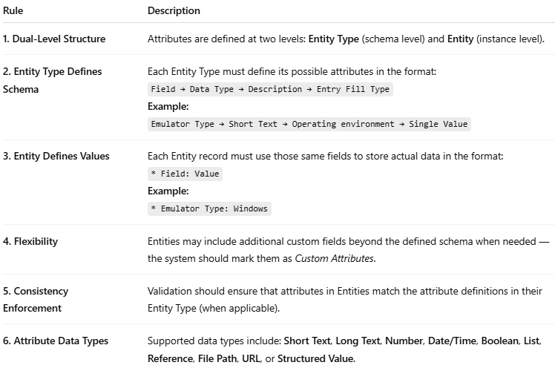
Rule | Description
1. Dual-Level Structure | Attributes are defined at two levels: Entity Type (schema level) and Entity (instance level).
2. Entity Type Defines Schema | Each Entity Type must define its possible attributes in the format:Field → Data Type → Description → Entry Fill TypeExample:Emulator Type → Short Text → Operating environment → Single Value
3. Entity Defines Values | Each Entity record must use those same fields to store actual data in the format:* Field: ValueExample:* Emulator Type: Windows
4. Flexibility | Entities may include additional custom fields beyond the defined schema when needed — the system should mark them as Custom Attributes.
5. Consistency Enforcement | Validation should ensure that attributes in Entities match the attribute definitions in their Entity Type (when applicable).
6. Attribute Data Types | Supported data types include: Short Text, Long Text, Number, Date/Time, Boolean, List, Reference, File Path, URL, or Structured Value.

